DEALS TO NAPA & SONOMA VALLEY

Wondering what to do in Napa Valley between visits to tasting rooms? While the world-class wineries in this region are undoubtedly a main attraction, there are plenty of other fabulous things to do in Sonoma Valley and Napa Valley.

(NAPA /SONOMA IMAGE HERE)

Find Deals From These Cities

INSERT FARE GRID FROM / TO Version (if available!)

   
Top Things To Do in Napa Valley & Sonoma Valley

Here are a few of the top attractions to try in Napa Valley and Sonoma Valley.

* Take a cooking class at the Silverado Cooking School, and you’ll impress family and friends back home with your fancy new culinary skills.
* Explore beautiful Wine Country on bike. With miles and miles of secondary roads and off-road bike trails, you can avoid riding along main highways, making this region a paradise for cyclists. Consider cycling from winery to winery on a tasting tour!
* Catch a show at one of the many performing arts centers in the area. The Uptown Theatre Napa and the Green Music Center in Sonoma are two top spots.
* Wine lovers aren’t the only ones who will have their complex palates satisfied in Napa and Sonoma Valleys. The craft beer scene in this region is hopping with both established brewpubs and new ventures.
* A list of what to do in Sonoma Valley wouldn’t be complete without mentioning the amazing locally sourced restaurants. Check out Oxbow Public Market as a place to start.

Travel Tips and Resources

[Must-Dos in Napa Valleyhttp://www.tripadvisor.com/Attractions-g580460-Activities-Napa_Valley_California.html](http://www.tripadvisor.com/Attractions-g580460-Activities-Napa_Valley_California.html)

[Napa Valley Hotelshttp://www.tripadvisor.com/Hotels-g580460-Napa_Valley_California-Hotels.html](http://www.tripadvisor.com/Hotels-g580460-Napa_Valley_California-Hotels.html)

[Napa Valley Restaurantshttp://www.tripadvisor.com/Restaurants-g580460-Napa_Valley_California.html](http://www.tripadvisor.com/Restaurants-g580460-Napa_Valley_California.html)

[Napa Valley Shopping Guidehttp://www.visitnapavalley.com/shopping.htm](http://www.visitnapavalley.com/shopping.htm)

[Napa Valley Nightlife and Entertainmenthttp://www.visitnapavalley.com/music_and_nightlife.htm](http://www.visitnapavalley.com/music_and_nightlife.htm)

[Napa Valley Travel Tipshttp://www.tripadvisor.com/Travel-g580460-s409/Napa-Valley:California:First.Time.Visitors.html](http://www.tripadvisor.com/Travel-g580460-s409/Napa-Valley:California:First.Time.Visitors.html)

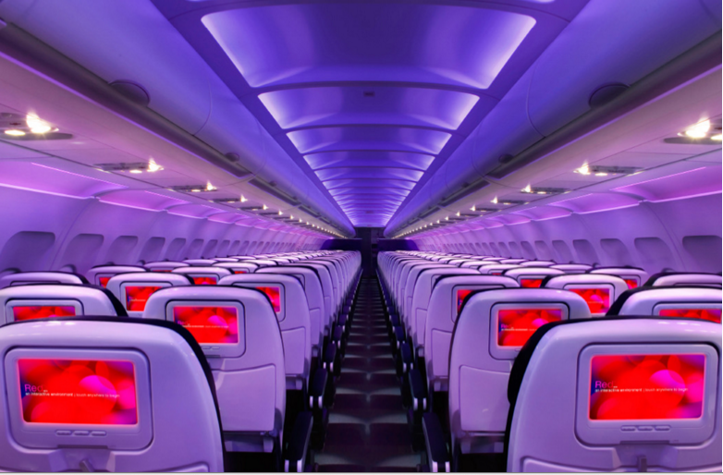

Main Cabin Main Cabin Select First Class

(add links to Cabin Class Pages)

Ready. Set. Fly.

Book your Mood-lit Ride to Napa & Sonoma Valley.

When looking into flights to Napa Valley, many people fly into San Francisco International and then take the short 90-minute drive to Napa so they can take in the magnificent scenery along the way. We highly recommend doing the same! Fly to SFO with Virgin America, and enjoy our plush leather seats, relaxing mood-lit cabins and the best in-flight entertainment in the sky. When you fly with us, you’ll get a taste of the good life before you even set foot in Napa.

Take a Virtual Tour

Add Terms & Conditions